Small Office Network Design and Implementation
Project Report
Project ID: NET-001
Author: Jerome Armah
Portfolio: Cybersecurity & Networking Portfolio
Version: 1.0
Date: 29 June 2026

Revision History
Version | Date | Author | Changes
1.0 | 29 Jun 2026 | Jerome Armah | Initial release

Table of Contents
Update in Microsoft Word by right-clicking the table and choosing Update Field after opening the document.
- Project Overview
- Client Requirements
- Project Objectives
- Hardware Inventory
- Network Topology
- VLAN Design
- IP Addressing Plan
- DHCP Configuration
- Router-on-a-Stick Configuration
- Wireless Configuration
- Testing & Validation
- Troubleshooting
- Skills Demonstrated
- Lessons Learned
- Recommendations
- Conclusion

Project Overview
This project implements a secure and scalable small office network using Cisco Packet Tracer. The solution includes VLAN segmentation, inter-VLAN routing, DHCP, wireless access, and centralized switching.

Client Requirements
Reliable connectivity, departmental separation, centralized addressing, wireless access for the meeting room, printer connectivity, and easy expansion.

Project Objectives
Design and implement a functional office network using best practices and validate end-to-end connectivity.

Hardware Inventory
Cisco 2911 Router
2 × Cisco 2960-24TT Switches
Wireless Access Point
Department PCs
Meeting Room Laptops
Network Printer

Network Topology
Figure 1: Packet Tracer topology used in Project NET-001.
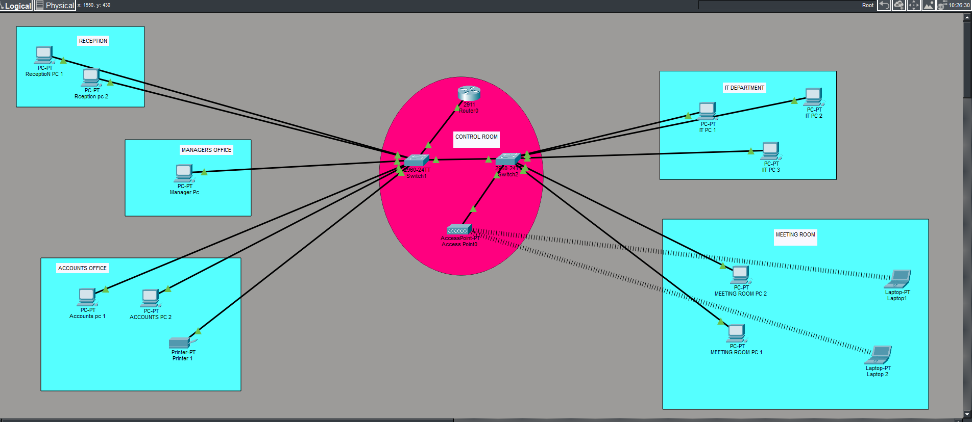

VLAN Design
VLAN 10 – Reception
VLAN 20 – Accounts
VLAN 30 – IT
VLAN 40 – Management
VLAN 50 – Meeting Room
VLAN 99 – Native/Management

IP Addressing Plan
Example addressing:
192.168.10.0/24
192.168.20.0/24
192.168.30.0/24
192.168.40.0/24
192.168.50.0/24

DHCP Configuration
DHCP pools were configured on the router to automatically assign addresses for each VLAN.

Router-on-a-Stick Configuration
Configured IEEE 802.1Q subinterfaces on the router for each VLAN with default gateway addresses.

Wireless Configuration
The wireless access point provides connectivity for meeting-room laptops using WPA2/WPA3 with DHCP from the router.

Testing & Validation
Verified DHCP leases, successful pings within and across VLANs, router reachability, printer accessibility, and wireless client connectivity.

Troubleshooting
A DHCP failure occurred because the switch port connected to the router was mistakenly configured as an ACCESS port instead of a TRUNK port. As a result, DHCP requests from multiple VLANs could not reach the router subinterfaces. The issue was resolved by changing the router-facing switch interface to trunk mode, allowing 802.1Q tagged traffic to pass correctly. DHCP immediately began assigning IP addresses to all VLANs.

Skills Demonstrated
Network design, VLAN implementation, subnetting, Router-on-a-Stick, DHCP, wireless networking, troubleshooting, documentation.

Lessons Learned
Correct trunk configuration is essential for inter-VLAN routing and DHCP relay between VLANs. Systematic testing speeds fault isolation.

Recommendations
Implement ACLs, enable port security, monitor with SNMP/Syslog, maintain backups, and document all configuration changes.

Conclusion
Project NET-001 successfully demonstrates practical enterprise networking skills suitable for a professional cybersecurity and networking portfolio.

